BANK LOAN SQL+ POWER BI

**Total Loan Applications**

SELECT COUNT(id) AS Total_Loan_Applications FROM bank_loan_data



**MTD Loan Applications**

SELECT COUNT(id) AS MTD_Total_Applications FROM bank_loan_data

WHERE MONTH(issue_date) = 12 AND YEAR (issue_date) =2021



**PMTD Loan Applications : (MTD-PMTD)/PMTD**

SELECT COUNT(id) AS PMTD_Total_Applications FROM bank_loan_data

WHERE MONTH(issue_date) = 11 AND YEAR (issue_date) =2021



**Total Funded Amount**

SELECT SUM(loan_amount) AS Total_Funded_Amount FROM bank_loan_data



**MTD Total Funded Amount**

SELECT SUM(loan_amount) AS MTD_Total_Funded_Amount FROM bank_loan_data

WHERE MONTH(issue_date) = 12 AND YEAR (issue_date) =2021



**PMTD Total Funded Amount**

SELECT SUM(loan_amount) AS PMTD_Total_Funded_Amount FROM bank_loan_data

WHERE MONTH(issue_date) = 11 AND YEAR (issue_date) =2021



**Total Amount Received**

SELECT SUM(total_payment) AS Total_Amount_Collected FROM bank_loan_data



**MTD Total Amount Received**

SELECT SUM(total_payment) AS MTD_Total_Amount_Collected FROM bank_loan_data

WHERE MONTH(issue_date)=12 AND YEAR(issue_date)=2021



**PMTD Total Amount Received**

SELECT SUM(total_payment) AS PMTD_Total_Amount_Collected FROM bank_loan_data

WHERE MONTH(issue_date) = 11 AND YEAR(issue_date)=2021



**Average Interest Rate**

SELECT ROUND(AVG(int_rate),4)*100 AS Avg_Int_Rate FROM bank_loan_data



**MTD Average Interest**

SELECT ROUND(AVG(int_rate),4)*100 AS MTD_Avg_Interest_Rate FROM bank_loan_data

WHERE MONTH(issue_date) =12 AND YEAR(issue_date) = 2021



**PMTD Average Interest**

SELECT ROUND(AVG(int_rate),4)*100 AS PMTD_Avg_Interest_Rate FROM bank_loan_data

WHERE MONTH(issue_date) =11 AND YEAR(issue_date) = 2021



**Avg DTI**

SELECT ROUND(AVG(dti),4)*100 AS Avg_DTI FROM bank_loan_data



**MTD Avg DTI**

SELECT ROUND(AVG(dti),4)*100 AS MTD_Avg_DTI FROM bank_loan_data

WHERE MONTH(issue_date) =12 AND YEAR(issue_date) = 2021



**PMTD Avg DTI**

SELECT ROUND(AVG(dti),4)*100 AS PMTD_Avg_DTI FROM bank_loan_data

WHERE MONTH(issue_date) =11 AND YEAR(issue_date) = 2021



**GOOD LOAN ISSUED**

**Good Loan Percentage**

SELECT

(COUNT(CASE WHEN loan_status = 'Fully Paid' OR loan_status = 'Current' THEN id END)*100)

/

COUNT(id) AS Good_Loan_Percentage

FROM bank_loan_data



**Good Loan Applications**

SELECT COUNT(id) AS Good_Loan_Applications FROM bank_loan_data

WHERE loan_status = 'Fully Paid' OR loan_status = 'Current'



**Good Loan Funded Amount**

SELECT SUM(loan_amount) AS Good_Loan_Funded_amount FROM bank_loan_data

WHERE loan_status = 'Fully Paid' OR loan_status = 'Current'



**Good Loan Amount Received**

SELECT SUM(total_payment) AS Good_Loan_Recieved_amount FROM bank_loan_data

WHERE loan_status = 'Fully Paid' OR loan_status = 'Current'



**BAD LOAN ISSUED**

**Bad Loan Percentage**

SELECT

    (COUNT(CASE WHEN loan_status = 'Charged Off' THEN id END) * 100.0) /

COUNT(id) AS Bad_Loan_Percentage

FROM bank_loan_data



**Bad Loan Applications**

SELECT COUNT(id) AS Bad_Loan_Applications FROM bank_loan_data

WHERE loan_status = 'Charged Off'



**Bad Loan Funded Amount**

SELECT SUM(loan_amount) AS Bad_Loan_Funded_amount FROM bank_loan_data

WHERE loan_status = 'Charged Off'



**Bad Loan Amount Received**

SELECT SUM(total_payment) AS Bad_Loan_amount_received FROM bank_loan_data

WHERE loan_status = 'Charged Off'



**LOAN STATUS**

SELECT

        loan_status,

        COUNT(id) AS LoanCount,

        SUM(total_payment) AS Total_Amount_Received,

        SUM(loan_amount) AS Total_Funded_Amount,

        AVG(int_rate * 100) AS Interest_Rate,

        AVG(dti * 100) AS DTI

    FROM

        bank_loan_data

    GROUP BY

        loan_status

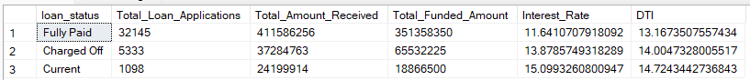

SELECT

loan_status,

SUM(total_payment) AS MTD_Total_Amount_Received,

SUM(loan_amount) AS MTD_Total_Funded_Amount

FROM bank_loan_data

WHERE MONTH(issue_date) = 12

GROUP BY loan_status

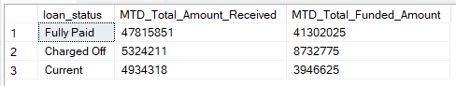

1. **BANK LOAN REPORT | OVERVIEW**

**MONTH**

SELECT

MONTH(issue_date) AS Month_Number,

DATENAME(MONTH, issue_date) AS Month_name,

COUNT(id) AS Total_Loan_Applications,

SUM(loan_amount) AS Total_Funded_Amount,

SUM(total_payment) AS Total_Amount_Received

FROM bank_loan_data

GROUP BY MONTH(issue_date), DATENAME(MONTH, issue_date)

ORDER BY MONTH(issue_date)

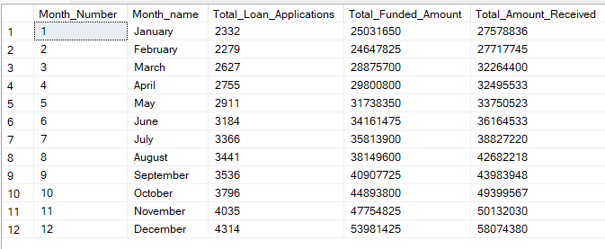

**STATE**

SELECT

address_state AS State,

COUNT(id) AS Total_Loan_Applications,

SUM(loan_amount) AS Total_Funded_Amount,

SUM(total_payment) AS Total_Amount_Received

FROM bank_loan_data

GROUP BY address_state

ORDER BY address_state

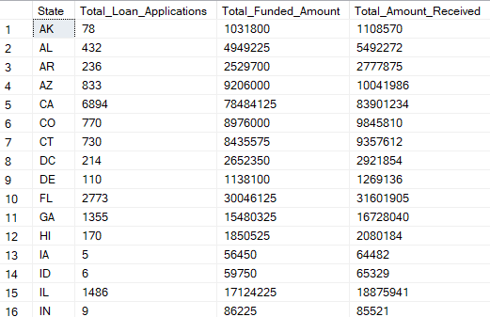

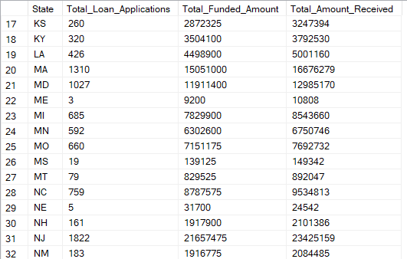

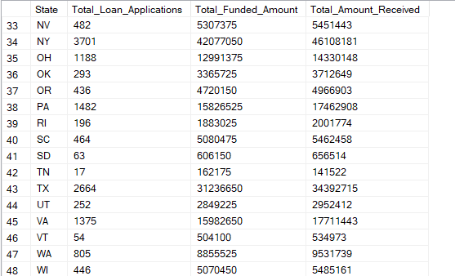



SELECT

address_state AS Max_State,

COUNT(id) AS Total_Loan_Applications,

SUM(loan_amount) AS Total_Funded_Amount,

SUM(total_payment) AS Total_Amount_Received

FROM bank_loan_data

GROUP BY address_state

ORDER BY SUM(loan_amount) DESC

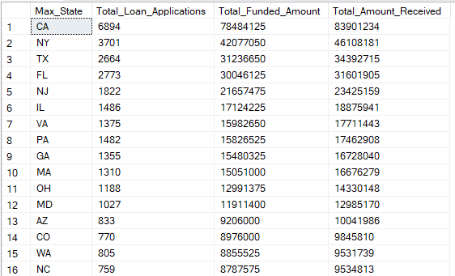

SELECT

address_state AS Max_Loan_App,

COUNT(id) AS Total_Loan_Applications,

SUM(loan_amount) AS Total_Funded_Amount,

SUM(total_payment) AS Total_Amount_Received

FROM bank_loan_data

GROUP BY address_state

ORDER BY COUNT(id) DESC

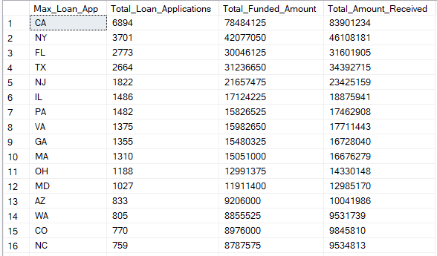

**TERM**

SELECT

term AS Term,

COUNT(id) AS Total_Loan_Applications,

SUM(loan_amount) AS Total_Funded_Amount,

SUM(total_payment) AS Total_Amount_Received

FROM bank_loan_data

GROUP BY term

ORDER BY term

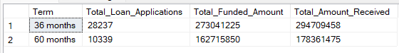

**EMPLOYEE LENGTH**

SELECT

emp_length AS Employee_Length,

COUNT(id) AS Total_Loan_Applications,

SUM(loan_amount) AS Total_Funded_Amount,

SUM(total_payment) AS Total_Amount_Received

FROM bank_loan_data

GROUP BY emp_length

ORDER BY emp_length

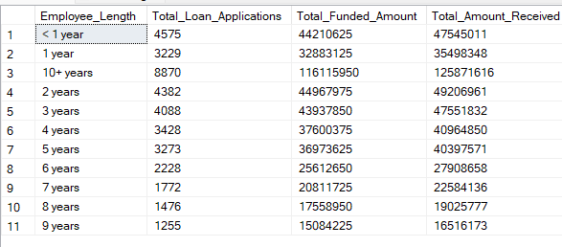

**PURPOSE**

SELECT

purpose AS PURPOSE,

COUNT(id) AS Total_Loan_Applications,

SUM(loan_amount) AS Total_Funded_Amount,

SUM(total_payment) AS Total_Amount_Received

FROM bank_loan_data

GROUP BY purpose

ORDER BY COUNT(id) DESC

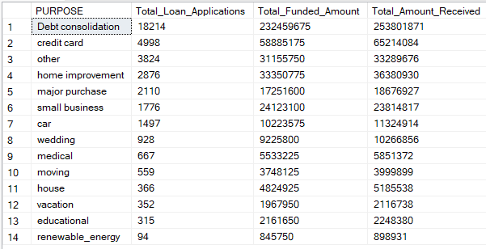

**HOME OWNERSHIP**

SELECT

home_ownership AS Home_Ownership,

COUNT(id) AS Total_Loan_Applications,

SUM(loan_amount) AS Total_Funded_Amount,

SUM(total_payment) AS Total_Amount_Received

FROM bank_loan_data

GROUP BY home_ownership

ORDER BY COUNT(id) DESC

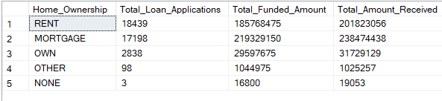

*Note: We have applied multiple Filters on all the dashboards. You can check the results for the filters as well by modifying the query and comparing the results.*

*For e.g*

*See the results when we hit the Grade A in the filters for dashboards.*

SELECT

home_ownership ,

COUNT(id) AS Total_Loan_Applications,

SUM(loan_amount) AS Total_Funded_Amount,

SUM(total_payment) AS Total_Amount_Received

FROM bank_loan_data

WHERE grade = 'A' AND address_state = 'CA'

GROUP BY home_ownership

ORDER BY COUNT(id) DESC

